Denis Doci

CS 412

HW 1

Problem 0)

a) What I hope to gain from this course is a greater understanding of how to implement machine learning solutions to projects. In my opinion machine learning is at the forefront of research in computer science and the future will involve a lot more implementation of these ideas. So, I hope to get an understanding of what these ideas are and why they are so sought after.

b) There is no certain type of data I’m interested in. However, I would like to learn more about abstract neural networks, and how to integrate them with sports statistics.

c) My experience in probability and statistics is limited. I have only take one statistics class here at UIC.

d) My experience in scientific programming languages is limited. However, I have experience in: Java, Python, C, C#, Objective C, Swift, and other programming languages.

Problem 1)

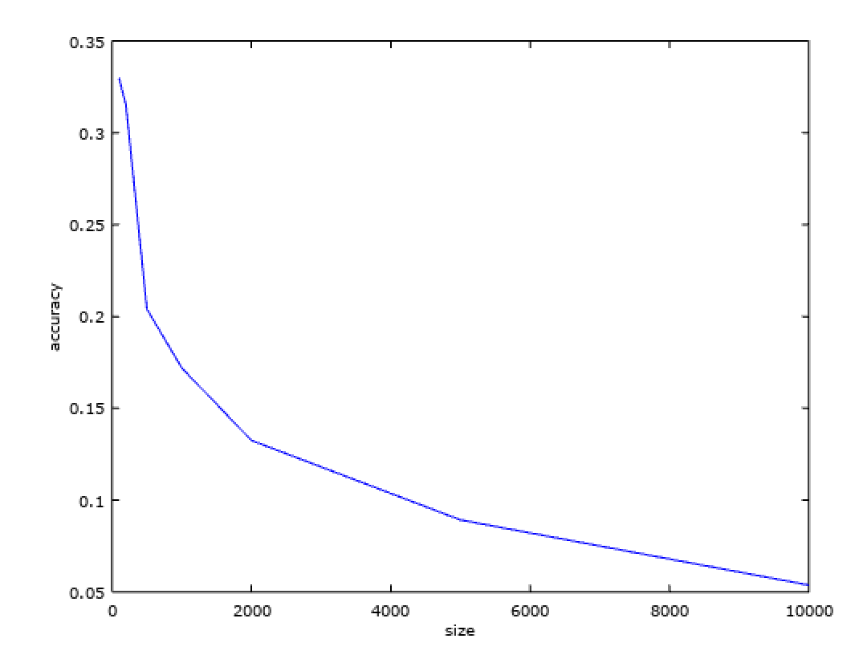

Training Examples Plot

Misclassified Example



Code Snippet

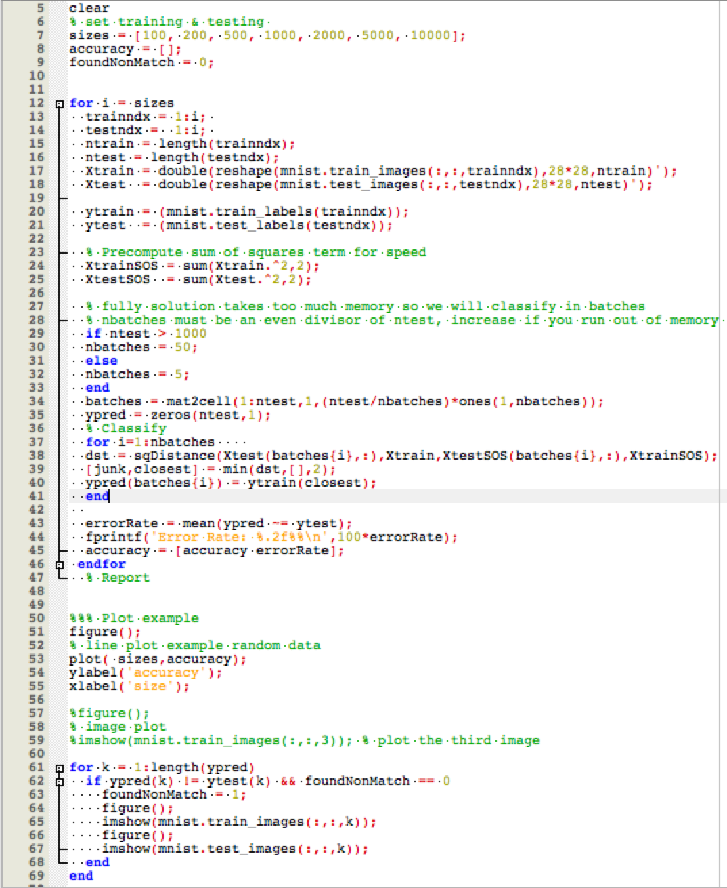

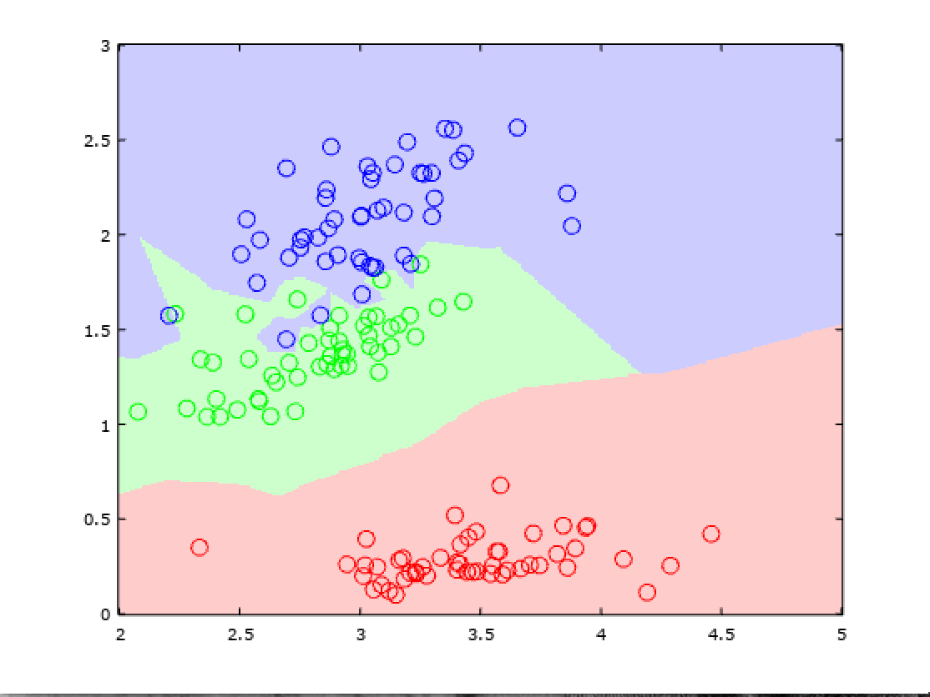

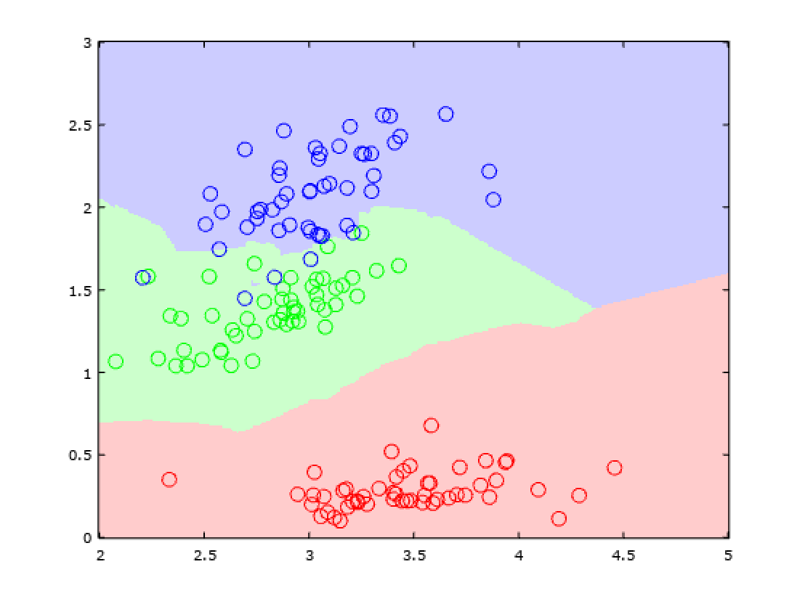

K=1 K =2

K=3 K=5

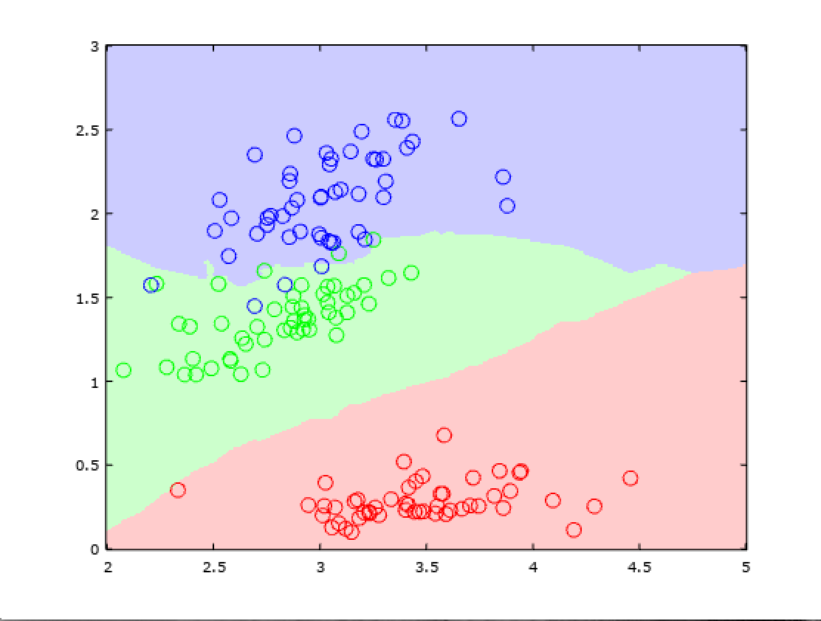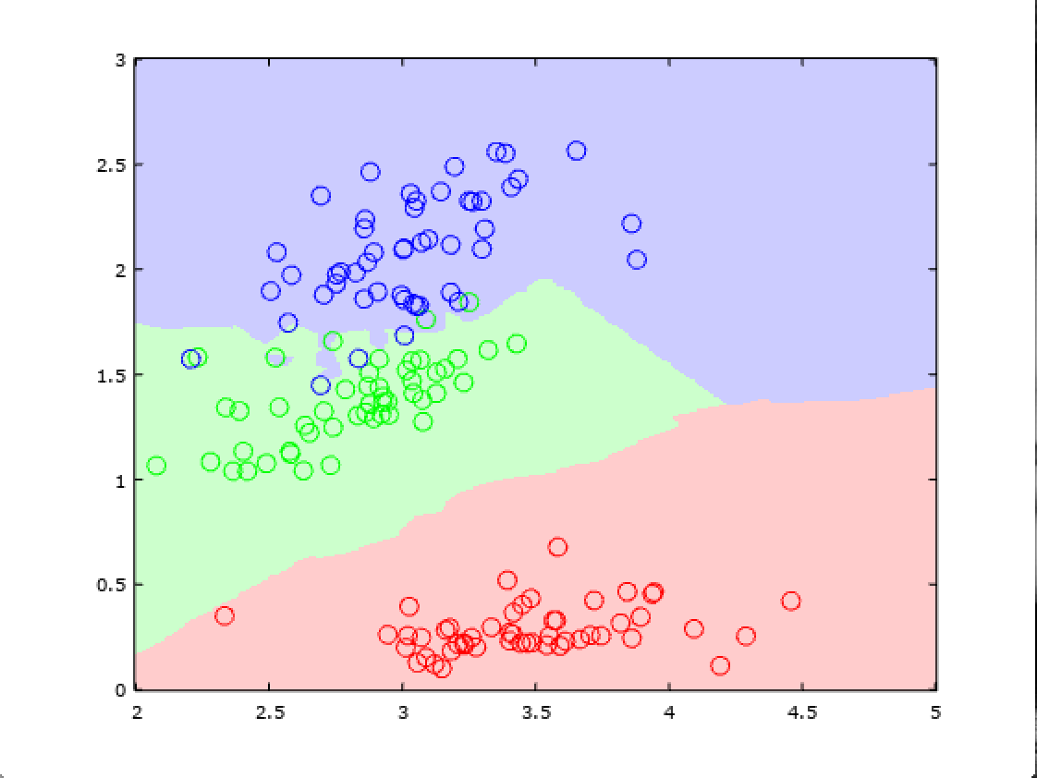

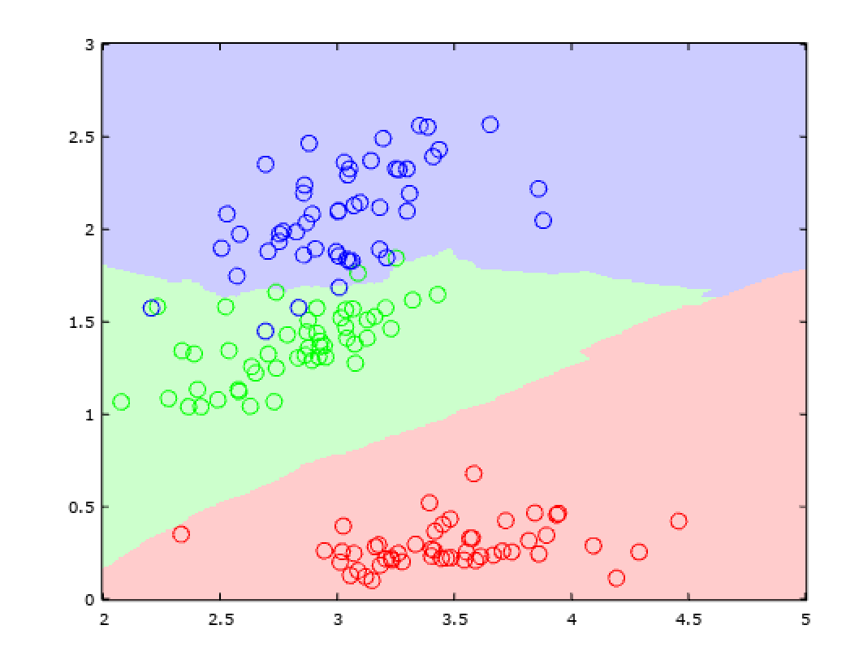

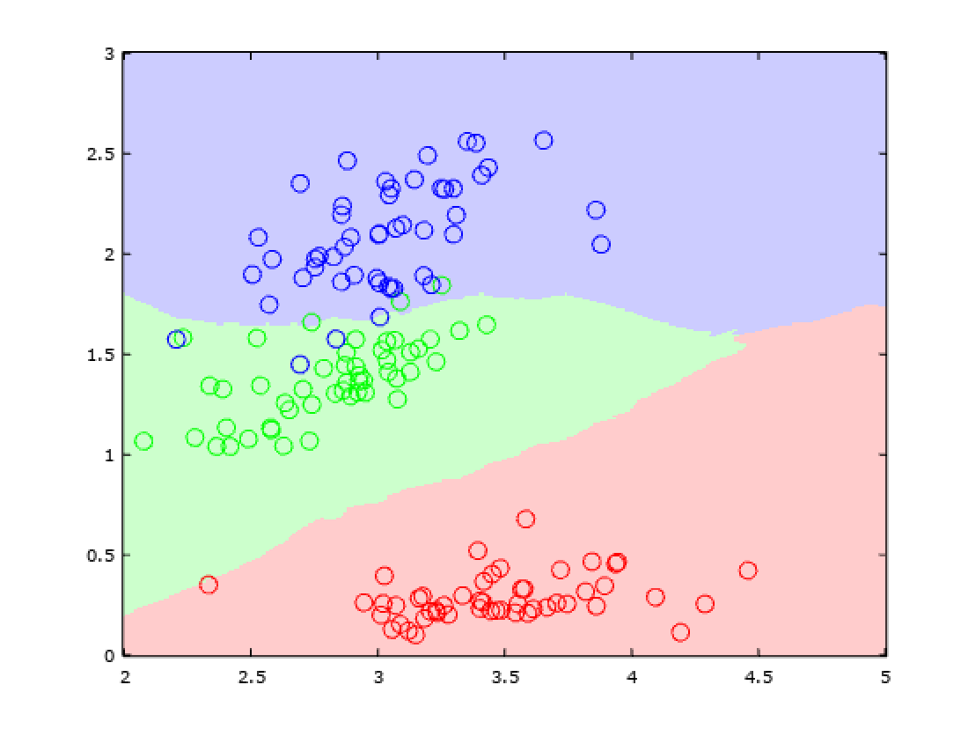 K= 10

K=15

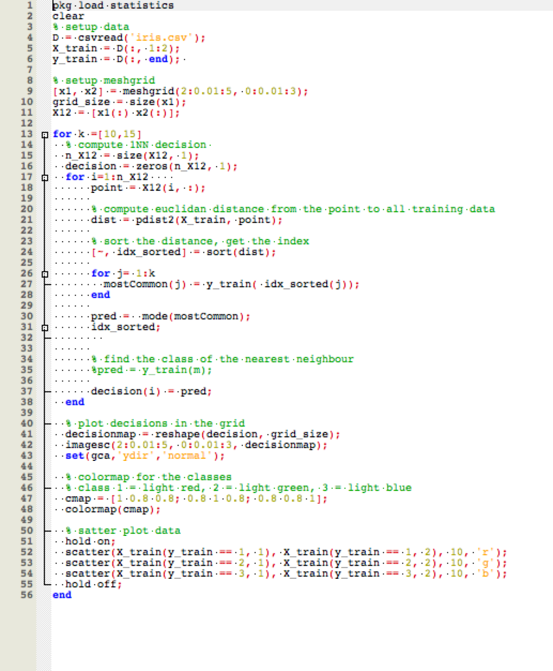

Iris Code